**THE CORAL ISLAND**

*R. M. Ballantyne*

Three boys, Ralph (the narrator), Jack and Peterkin, are the sole survivors of a shipwreck on the coral reef of a large but uninhabited Polynesian island. At first their life on the island is perfect; food, in the shape of fruits, fish and wild pigs, is plentiful, and using their only possessions; a broken telescope, an iron-bound oar and a small axe, they fashion a shelter and even construct a small boat. Their first contact with other people comes after several months when they observe……. *(1)*

“A sail! a sail! Ralph, Jack, look! Away on the horizon there, just by the entrance to the lagoon!” cried Peterkin, as we scrambled up the rocks. “So it is, and a schooner, too!” said Jack, as he proceeded hastily to scramble into the rags of our clothing. *(2)*

Our hearts were thrown into a terrible flutter by this discovery, for if it should touch at our island we had no doubt the captain would be happy to give us a passage to some of the civilized islands, where we could find a ship sailing for England, or some other part of Europe, from where we could easily make out way home. With joyful anticipations we hastened to the highest point of rock near our dwelling, and awaited the arrival of the vessel, for we now perceived that she was making straight for the island, under a steady breeze. *(3)*

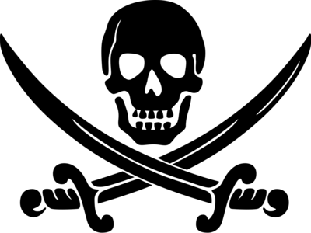

In less than an hour she was close to the reef, where she rounded to, and backed her topsails in order to survey the coast. Seeing this, and fearing that they might not perceive us, we all three waved pieces of cocoa-nut cloth in the air, and soon had the satisfaction of seeing them beginning to lower a boat and bustle about the decks as if they meant to land. Suddenly a flag was run up to the peak, a little cloud of white smoke rose from the schooner's side, and, before we could guess their intentions, a cannon-shot came crashing through the bushes, carried away several cocoa-nut trees in its passage, and burst in atoms against the cliff a few yards below the spot on which we stood. *(4)*

With feelings of terror we now observed that the flag at the schooner's peak was black, with a Death's head and cross bones upon it. As we gazed at each other in blank amazement, the word “pirate” escaped our lips simultaneously. *(5)*

“What is to be done?” cried Peterkin, as we observed a boat shoot from the vessel's side, and make for the entrance of the reef. “If they take us off the island, it will either be to throw us overboard for sport, or to make pirates of us.” *(6)*

I did not reply, but looked at Jack, as being our only resource in this emergency. He stood with folded arms, and his eyes fixed with a grave, anxious expression on the ground. “There is but one hope,” said he, turning with a sad expression of countenance to Peterkin; “perhaps, after all, we may not have to resort to it. If these villains are anxious to take us, they will soon overrun the whole island. But come, follow me.” *(7)*

Stopping abruptly in his speech, Jack bounded into the woods, and led us by a circuitous route to Spouting Cliff. Here he halted, and, advancing cautiously to the rocks, glanced over their edge. We were soon by his side, and saw the boat, which was crowded with armed men, just touching the shore. In an instant the crew landed, formed line, and rushed up to our shelter. Now, boys, we have but one chance left,--the Diamond Cave.” *(8)*

We spent an anxious but quite comfortable night in the cave since we’d left food supplies there for just such an emergency as this. In the morning, I woke first and determined to discover what was up with our unexpected and undesirable ‘guests’. I did not wake my friends, knowing they would do their best to dissuade me from taking such a risk. So leaving them soundly sleeping, out of the cave and off to the beach I crept. *(9)*

Standing on the warm, golden sand, I was thrilled and relieved to see no sign of the pirates’ schooner. I scanned the horizon for a full minute, then gave vent to a deep sigh of relief: “Yes, they’ve gone. Those villains have been deprived of their prey this time.” *(10)*

“Don’t be sure of that, puppy!” said a deep voice at my side; while, at the same moment, a heavy hand grasped my shoulder, and held it as if in a vice.