**Just Grow Up!**

In this article from *The Monitor* Saturday 26 January 2013, Mike Milton discusses why it’s a waste of time telling the children to ‘Just Grow up!’

Sooner or later as a parent, you will turn to one of your [children](http://www.guardian.co.uk/society/children) and utter the words you once swore to yourself you would never use: “Just grow up.” I can't remember when I started to tell my kids to grow up – or, even more absurdly, to ‘stop acting like a child’ – but I am aware of the magnetic pull of the phrase. *(1)*

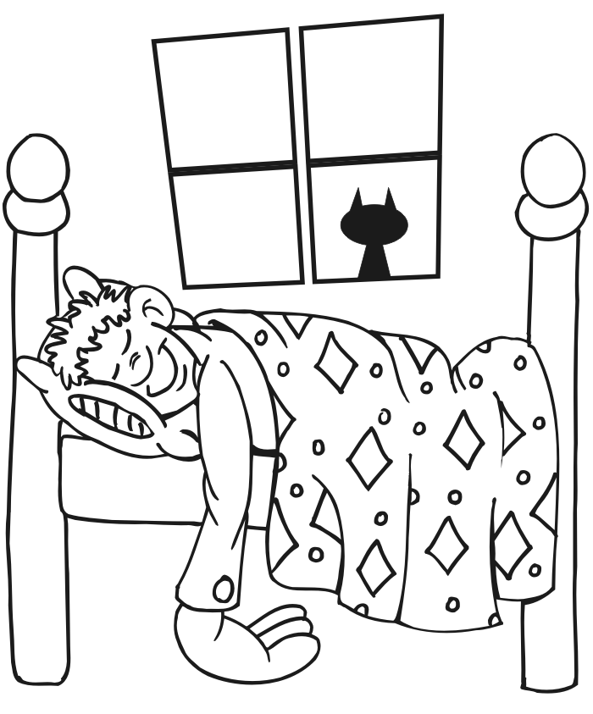I can remember the last time I used the phrase – last Friday at 8.10 in the a.m. How can I be so precise? Because I was looking at my watch as I said it while advising my off-spring to get off his sad **** and into his school uniform. The afore-mentioned offender was lying flat out on his bed, arms folded across his chest, apparently absorbed by shadows on the ceiling. I tried hard, believe me I did, but to no avail. “Get off that bed and just grow up!.” *(2)*

Leo raised his head minimally, turned his eyes towards me, minimally, and muttered: “Oh, dad, chill out. I just need some down time.” *(3)*

Leo is 11 years old. *(4)*

At that moment, I wasn't amused, but looking back on it, it was, if not funny, then least ironic. One treasures more than anything that special quality children have – childishness – and yet one is simultaneously on a mission to destroy it. It is the sad duty of parents to remove the golden dust of childhood, layer by layer, by insisting on the necessities of life – by imparting the knowledge that arrangements once made must be kept to (including school), that certain spontaneous behaviours, such as dropping your underpants and showing everyone on the M2 your bum while giggling hysterically, are not, in the long run, acceptable (Leo 9, September 2010). *(5)*

I am fairly atypical in that I have always wanted to grow up – even when I was very young. To be a man rather than a boy seemed to be a worthy goal – to acquire dignity, wisdom, a measured, perhaps even Olympian view of life. Yet the process of having children yourself ultimately removes from the hope of ever really reaching maturity because their childishness brings out the child in you, and reminds you how tedious being grown up can be. *(6)*

So, while insisting that Leo get into his school uniform and into the car almost simultaneously, I find myself saying, “Fancy stopping off for a knickerbocker glory on the way”, and am rewarded by hearing Leo whoop, “Yay, that’s my dad talking now!” *(7)*

1. In *(1),* which phrase indicates the writer found it almost impossible

to resist telling his children ‘to grow up’? 1 mark

2. Why do you think the Leo’s father gives such precise details in *(2)*? 2 marks

3. Why do you think Leo’s father got so ‘uptight’ in *(2)*? 1 mark

4. In *(3)* why does the writer repeat the word ‘minimally’? 1 mark

5. Why is paragraph 4 confined to a single sentence? 1 mark

6. According to *(5)*, what impossible and ironic position do parents

find themselves in when bringing up their children? 2 marks

7. Why are we given the specific information in the brackets in *(5)*? 1 mark

8. In what sense was the writer ‘atypical’ when growing up? *(6)* 1 mark

9. Why does having children prevent parents from becoming too mature

too early on? Does the writer approve or disapprove of this? *(6)* 2 marks

10. What’s the significance of Leo’s whoop at the end of the article? 2 marks