PETER PAN
JM Barrie

It might be difficult to find any child anywhere in the world who has never heard of Peter Pan, the only boy in all the world who never grows up. Peter Pan spends his never-ending childhood having adventures on the small island of Neverland where he leads his gang, the Lost Boys in a world of mermaids, Indians, fairies, pirates, and occasionally ordinary children from the world outside. In this extract Peter finally comes face to face with his arch-enemy, Captain James Hook.

HOOK OR ME THIS TIME

Suddenly Hook found himself face to face with Peter. The others drew back and formed a ring around them. For long the two enemies look at one another, Hook shuddering slightly, and Peter with a strange smile on his face.
“So, Pan,” said Hook at last, “this is all your doing.”
“Ay, James Hook,” came the stern answer, “it is all my doing.”
“Proud and insolent youth,” said Hook, “prepare to meet thy doom.”
“Dark and sinister man,” Peter answered, “have at thee.”
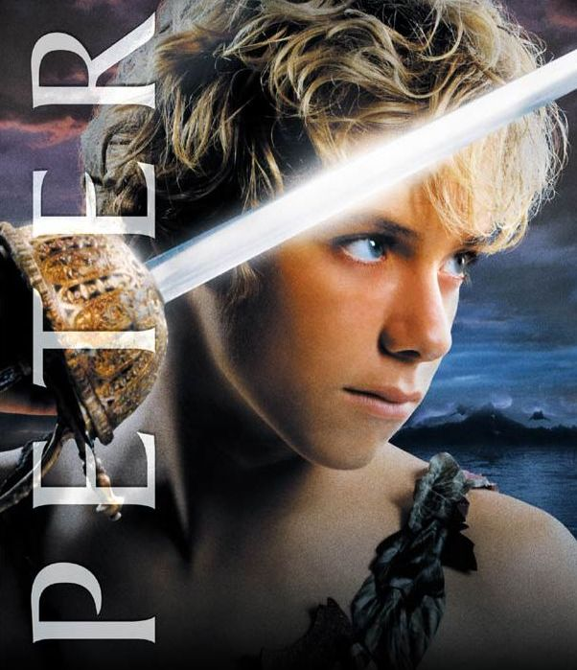
Without more words they fell to, and for a space there was no advantage to either blade. Peter was a superb swordsman, and parried with dazzling rapidity; ever and anon he followed up a feint with a lunge that got past his foe's defence, but his shorter reach stood him in ill stead, and he could not drive the steel home.
Then he sought to close in and finish Peter off with his iron hook, which all this time had been pawing the air; Peter doubled under it and, lunging fiercely, pierced him in the ribs. At the sight of his own blood, whose peculiar colour, you remember, was offensive to him, the sword fell from Hook's hand, and he was at Peter's mercy.
“Now!” cried all the boys, but with a magnificent gesture Peter invited his opponent to pick up his sword. Hook did so instantly, but with a tragic feeling that Peter was showing good form. Hook was fighting now without hope, but there was one thing left he could do – he, James Hook, was a gentleman, but before he went into the cold and dark he would show that Peter Pan was not!
Abandoning the fight he rushed into the powder magazine and fired it. “In two minutes,” he cried, “the ship will be blown to pieces.”
“Now I shall show that Peter Pan is a coward,” he thought. But calmly Peter picked up the powder barrel, shook it by his ear, and just as calmly through it over the side of the ship where it exploded with a tremendous Bang!
It was almost all over for Captain Hook, and he knew it. The boys danced around him, teasing him, taunting him, the youngest even daring to stick out their tongues at him. O, the shame of it!
Backwards, always backwards, staggered Hook until he was the farthest end of the gangplank where so many had been forced to fall into the sea. And, seeing the boy advance towards him along the plank, he turned ready to let himself fall into the sea.
But wait! We must not let Captain James Hook die such an ignoble death. He has been a grand enemy for the boy, so we shall allow him one last triumph. The man reaches the end of the gangplank. He turns his back on the boy and bends over to look into the deep blue sea. And Peter, quite forgetting his manners, boots him up the backside. And down goes James Hook, down, down, into the jaws of the crocodile who has paddled patiently around waiting for this delicious moment.
“Farewell, you rude boy,” he smiles, as he disappears content at last.

1. What does the title of this extract suggest?
2. Why do you think the smile on Peter’s face is described as ‘strange’?
3. Compare how Peter and Captain Hook describe each other in paragraphs 4 and 5?
4. How does Barrie convey the fierceness of the fight in the paragraph
beginning Without more words....? Give specific examples of the language used.
5. When Hook picks up his sword, what mixed emotions does he feel?
6. How does Hook fail to show that Peter is a coward at heart?
7. In the paragraph beginning It was almost over, how does the author begin to create
some sympathy for Captain James Hook? Why does the author do this?
8. Why does Hook bend over to look down into the deep blue sea?
9. Comment on the use of the phrase delicious moment that describes the end
of James Hook.
10. Why do you think James Hook is content at last?

